MAIN SUB PAGE
STEEL SIDING & SOFFIT
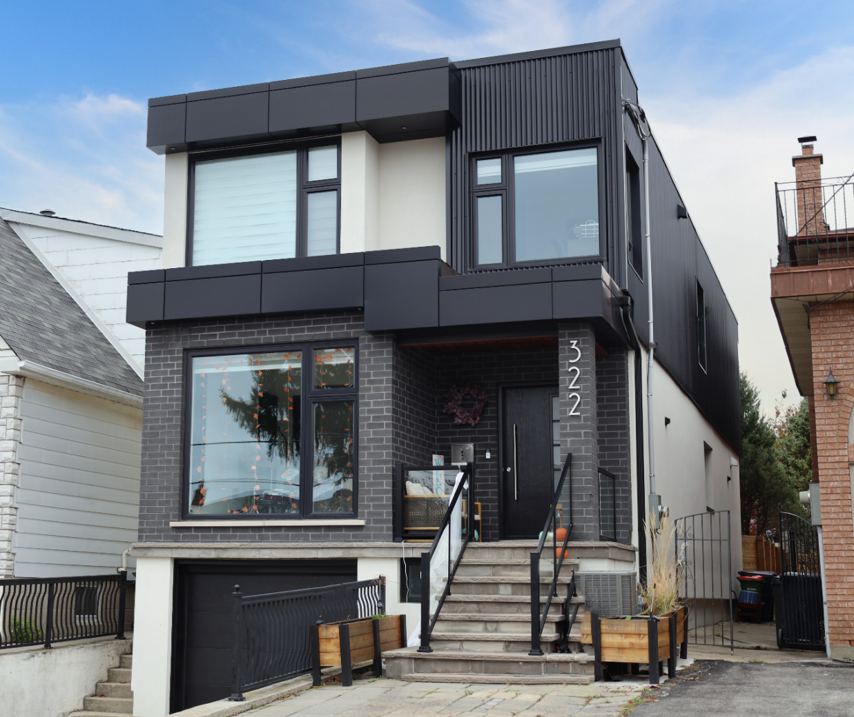
Industrial / Residential / Commercial / Agricultural
Durable, stylish, and cost-effective, metal siding panels offer a modern and long-lasting solution for residential and commercial projects. Made from high-quality steel, these panels provide excellent protection against harsh weather, fire, and pests while enhancing energy efficiency. Their low maintenance requirements and longevity make them a budget-friendly choice over time. With a variety of profiles, finishes, and colors available, metal siding delivers both aesthetic appeal and structural resilience, making it a smart investment for any building.
Curious about the advantages of steel siding? Visit our blog to explore the compelling reasons why this choice stands out for homeowners seeking durability and style.
Speak with an Expert Get personalized advice and expert guidance to achieve your project goals with confidence.
HIDDEN FASTENING (HF) SERIES MENU ICON (PREVIEW)

HIDDEN FASTENER (HF) SERIES Steel Siding & Soffit
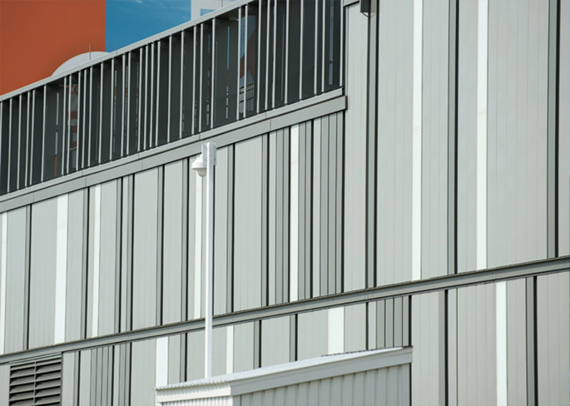
Hidden or Concealed fastening steel siding systems offer a clean, modern aesthetic with exceptional performance across residential, commercial, and industrial applications.... (Learn More / Expand)

HIDDEN FASTENER (HF) SERIES Steel Siding & Soffit (EXPANDED)
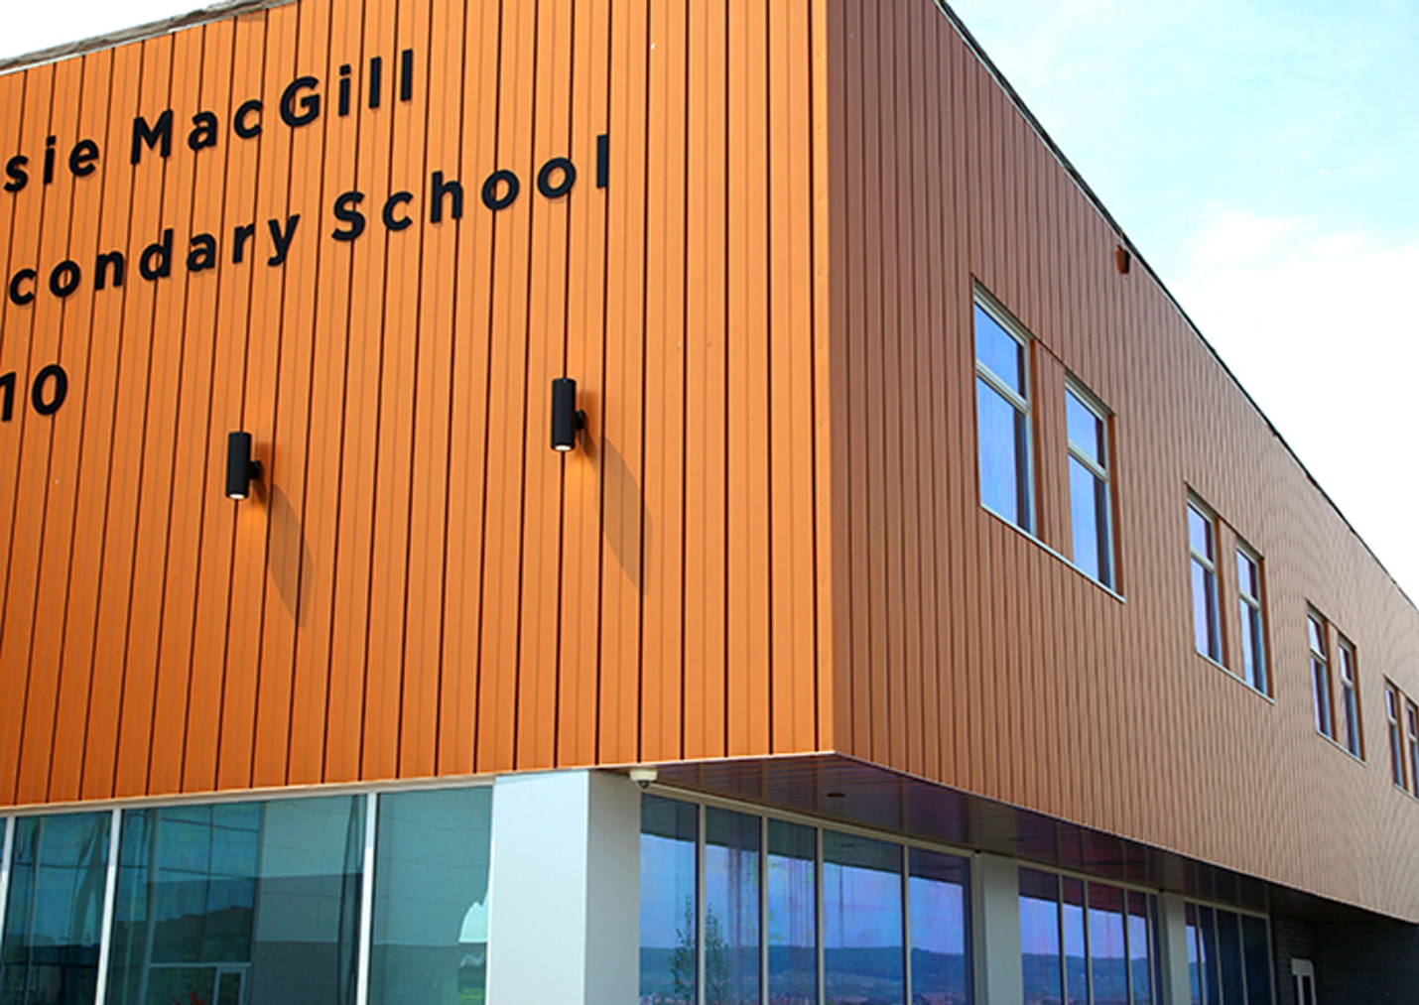
Expanded …By hiding fasteners behind interlocking panels, these systems provide a sleek, uninterrupted exterior surface that enhances visual appeal while improving long-term durability. The concealed design not only protects fasteners from weather exposure and corrosion but also reduces maintenance needs and increases lifespan. With a variety of profiles, colors, and finishes available, these systems deliver both architectural versatility and structural integrity—making them an ideal solution for projects demanding style, strength, and reliability

1- AGWAY SOFFIT MENU ICON (PREVIEW)

Agway Steel Soffit
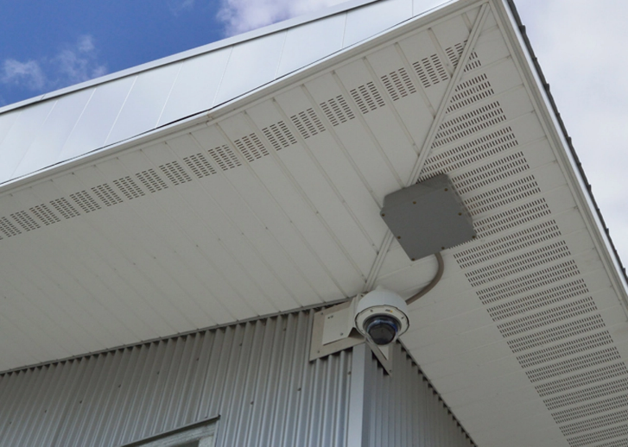
Agway’s ICI soffit panels offer a flexible, user-friendly solution with a variety of options, including custom flat panels to suit any design. .... (Learn More / Expand)

AGWAY® SOFFIT HIDDEN FASTENER (HF) SERIES (EXPANDED)
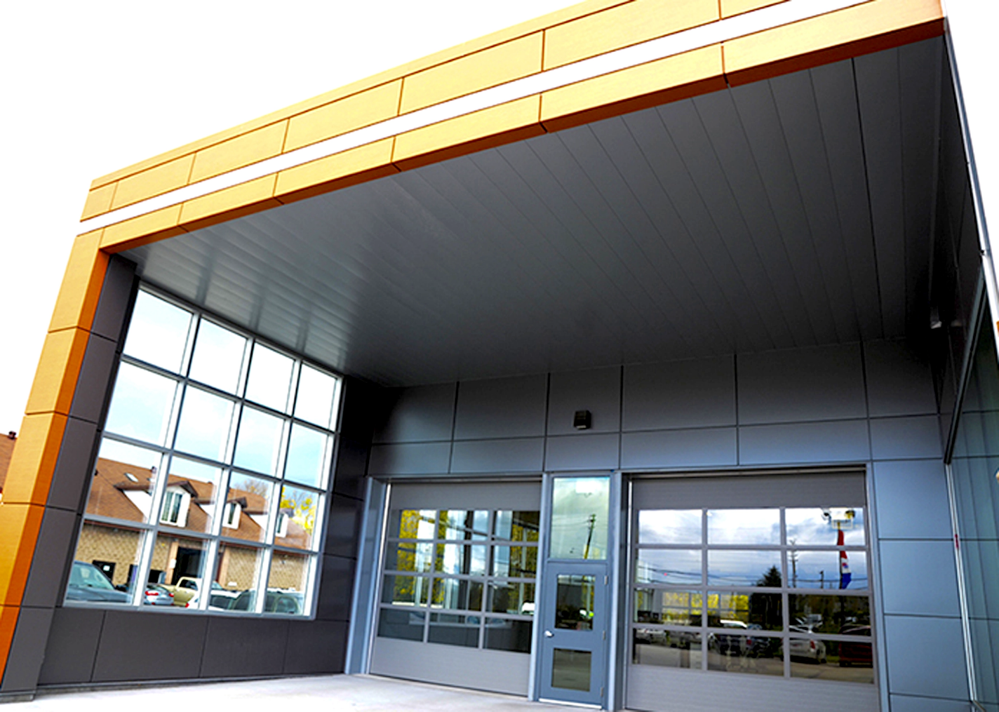
Expanded … Agway’s ICI soffit panels offer a flexible, user-friendly solution with a variety of options, including custom flat panels to suit any design.
Available in tailored lengths and an extensive range of standard and custom colors and finishes, these panels are designed for easy handling and straightforward installation.

Profiles Options:

V-Rib Soffit Panels

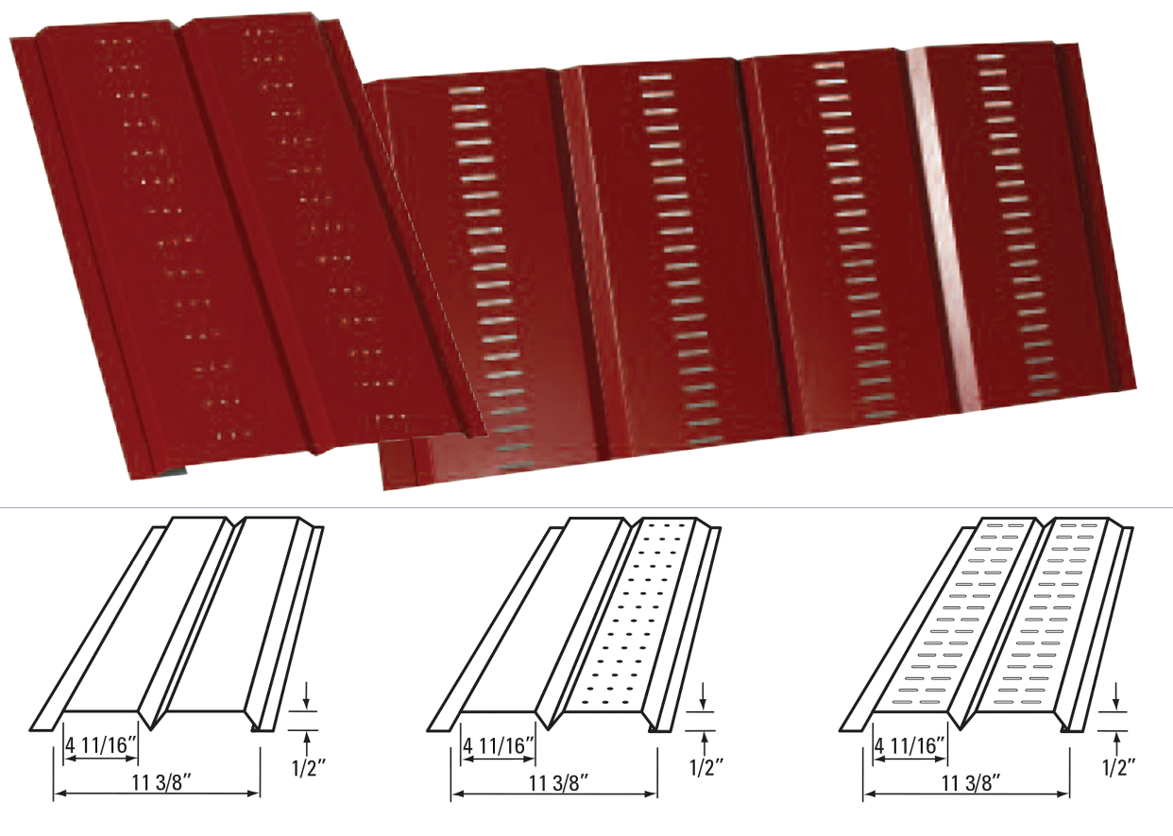

Key Features:
- Custom-fabricated in lengths ranging from 1’ to 12’
- Perforation options available up to full 12’ lengths
- Offered in 29-, 26-, and 24-gauge thicknesses
- Venting available with either slotted or round perforations
- Reinforced with optional V-Rib or Bubble Rib stiffeners
- Max lengths: 12’ for V-Rib, 10’ for Bubble Rib
- Manufactured from pre-painted steel, aluminum, copper, stainless steel, or zinc
- Supplied pre-cut to your specified dimensions—no on-site trimming required
- Clean, finished look enhances visual appeal
- Straightforward installation—secure to the underside of eaves using nails or screws

Vented Soffit CH5-32 (Special Order Only)

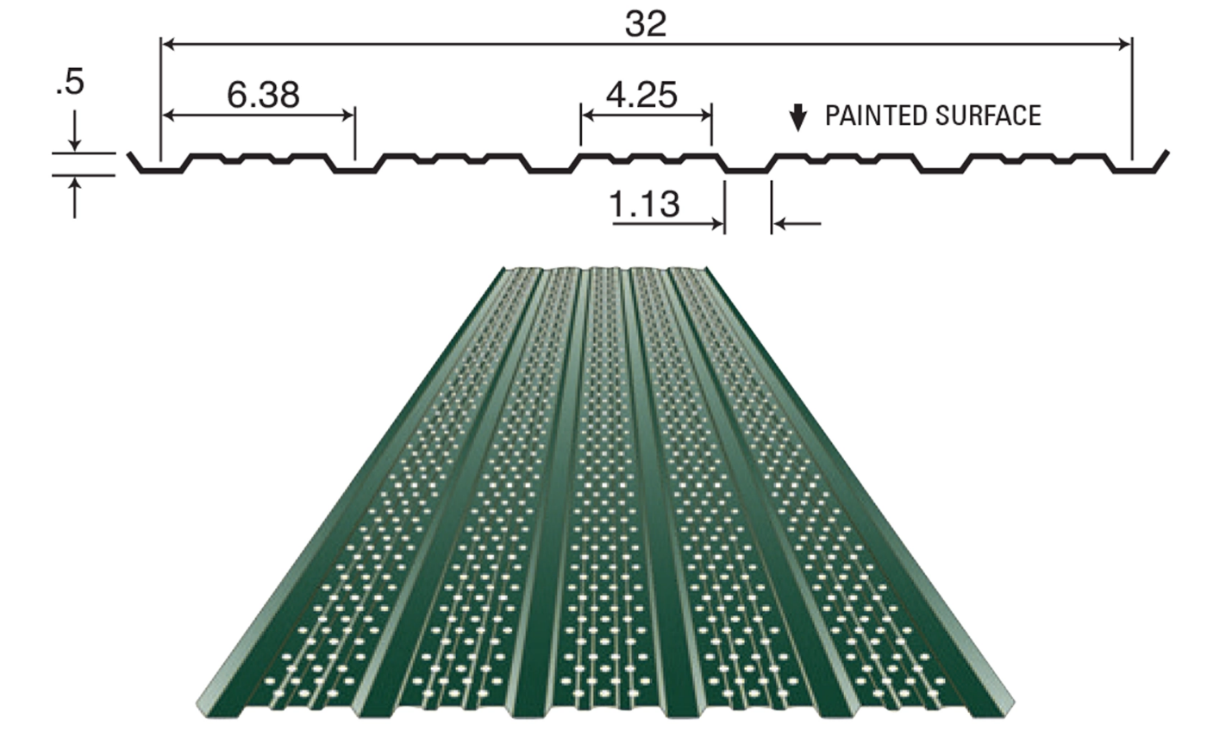
Features:
- Manufactured in custom rollformed lengths ranging from 10 inches up to 45 feet
- Continuous ventilation pattern on the top face with 1/8” diameter holes spaced at 3/8” intervals
- Additional color options may be available—please reach out to our estimating team for availability
- Offers a high-performance ventilation rate with 6% open air space

Agri Soffit Panels

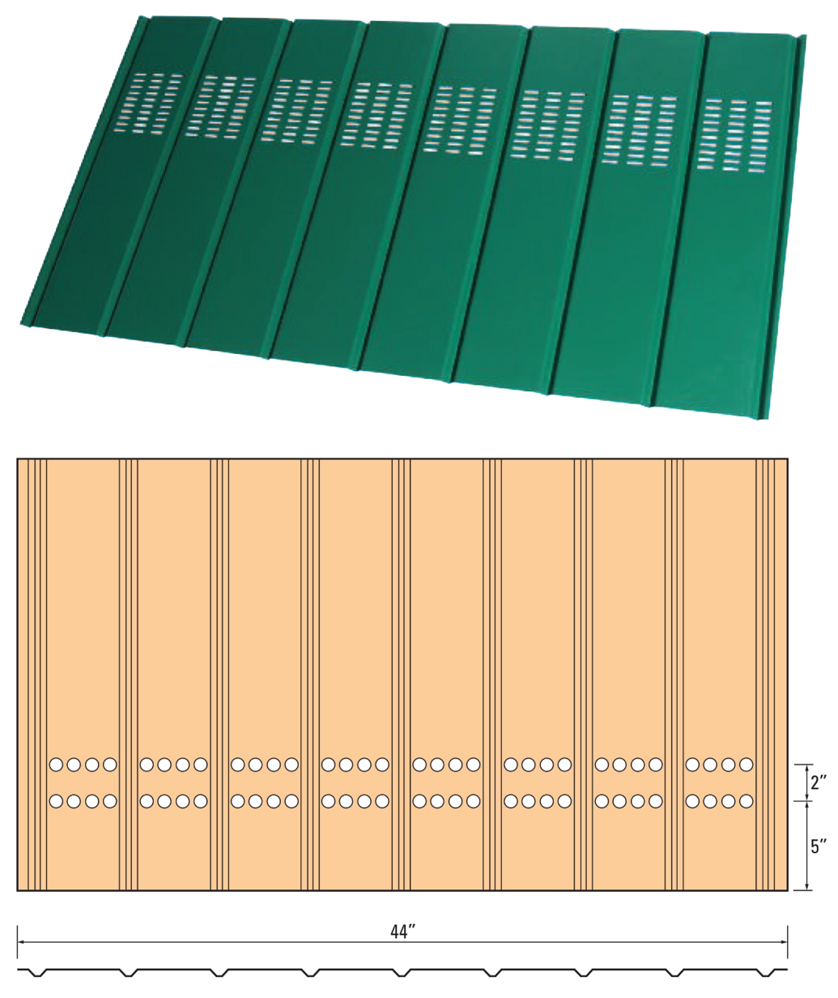

Key Product Highlights
- Produced from high-quality 26 or 29-gauge pre-painted steel
- Material options include steel, aluminum, copper, stainless steel, and zinc
- Custom-fabricated in lengths up to 10 feet
- Precision cut to exact measurements—no on-site trimming required
- Clean, modern appearance enhances building aesthetics
- Simple to install—fastens easily with nails or screws under roof overhangs

Common Uses
- Non-Vented Option: Ideal for enclosing the underside of roof overhangs (soffits)
- Vented Option: Supports natural airflow into the structure for balanced ventilation
- Available venting styles include round or slotted perforations
- Can be paired with roof ventilation systems for enhanced air circulation

Additional Notes:
- Please note: Oil canning may naturally occur due to material and installation variables.
- This is a visual phenomenon and does not qualify as a product defect.

Color chart

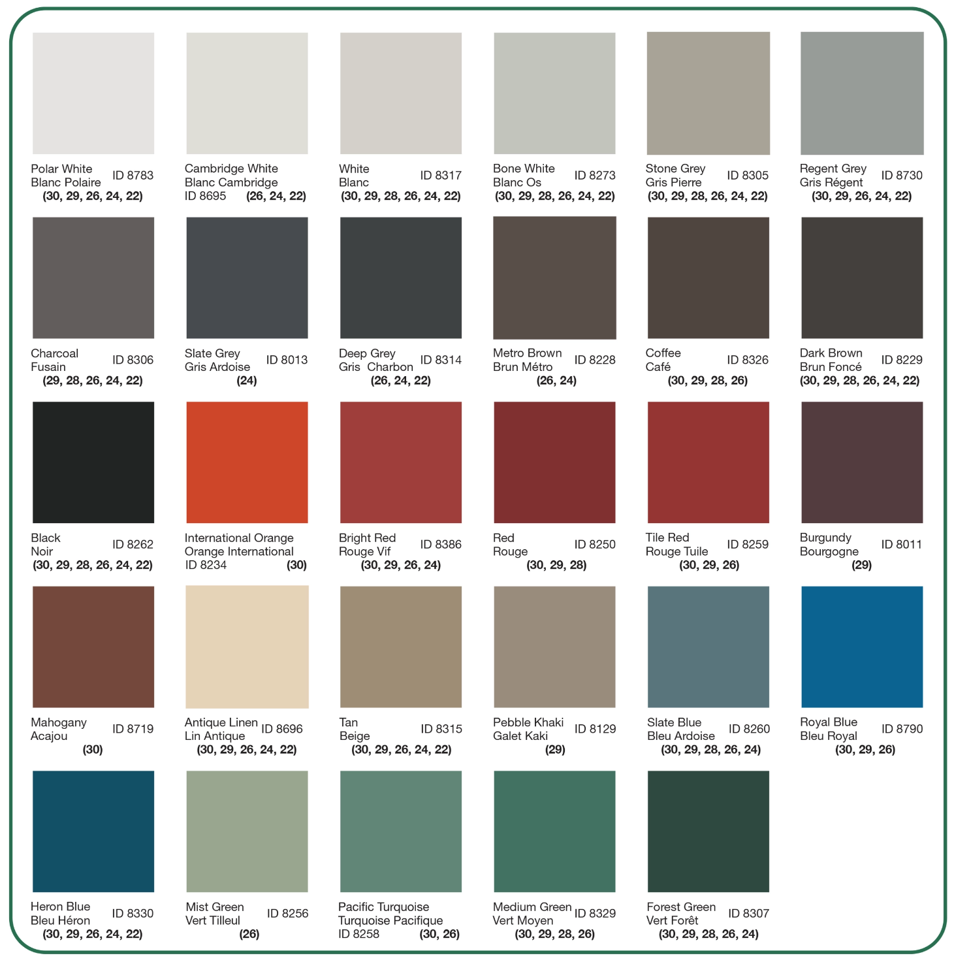

Standard and Custom Flashings
If you need a specific flashing shape, we can fabricate it. Cladcan provides a full range of flashings and trims to complete your commercial or industrial building project. From outside corners to jambs and coping flashings, we’ve got you covered.

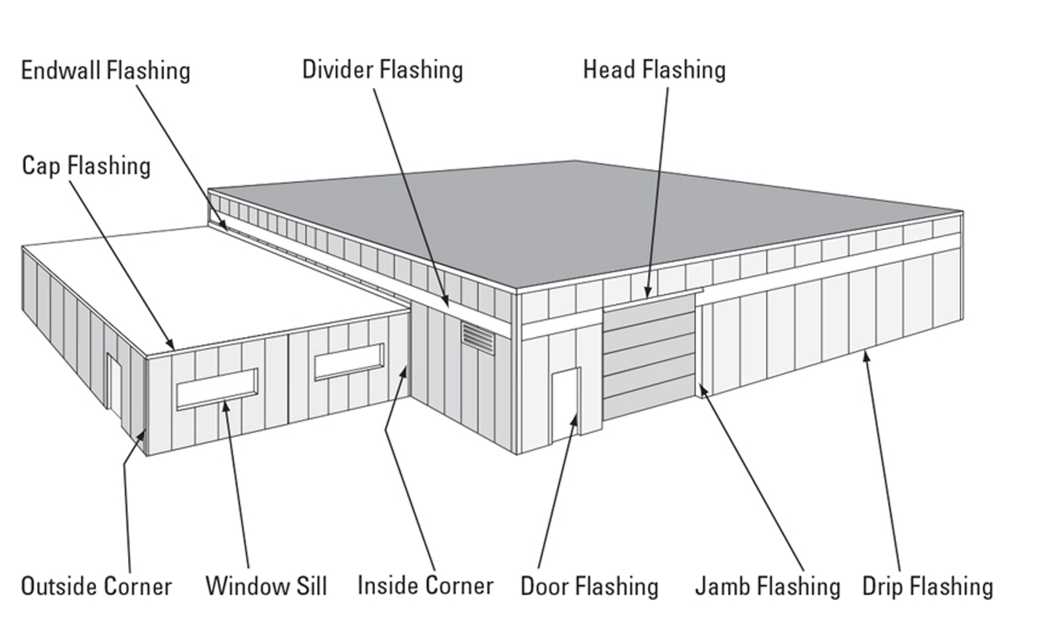

Outside and Inside Corners
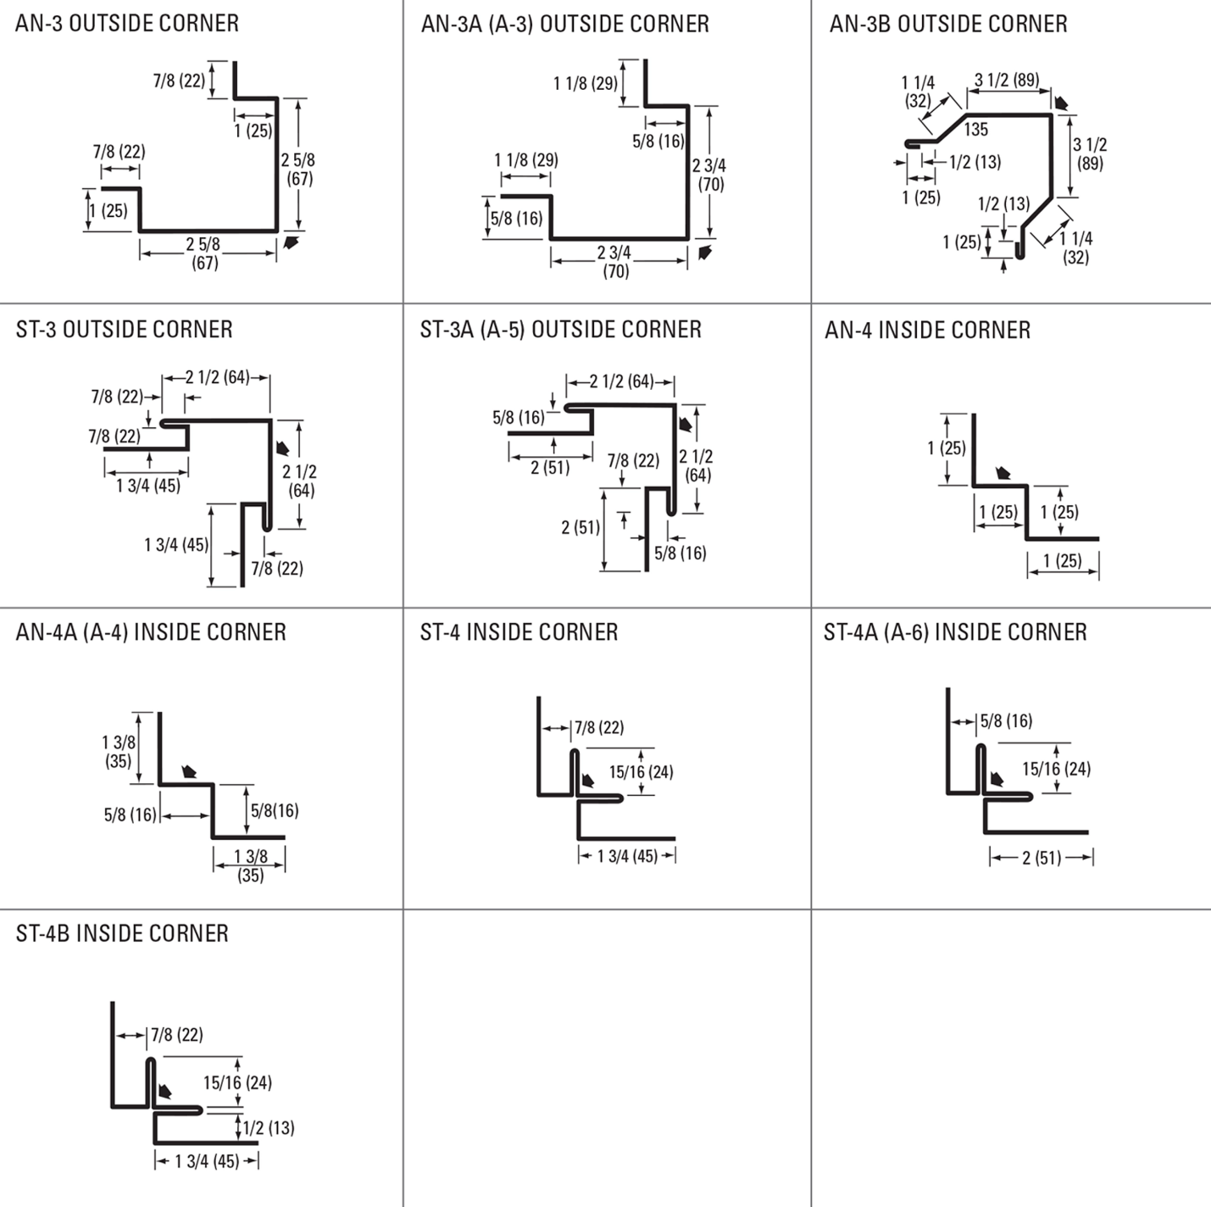

Drip and base Trims, Gable Dividers
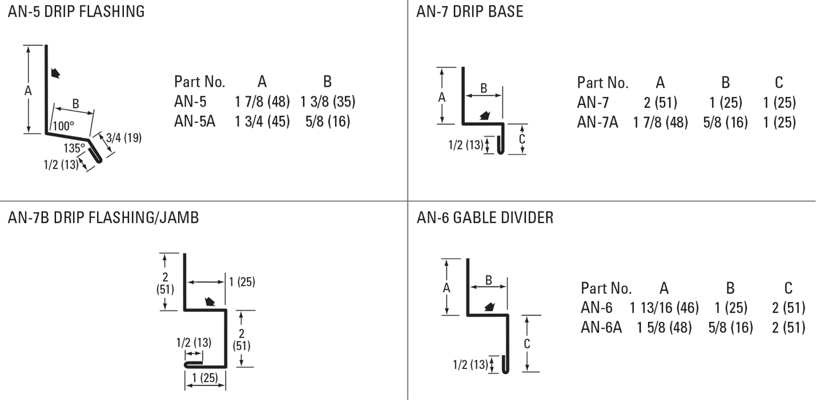
Soffit & Gable Trims, Eaves Starters, Jamb Fkashings
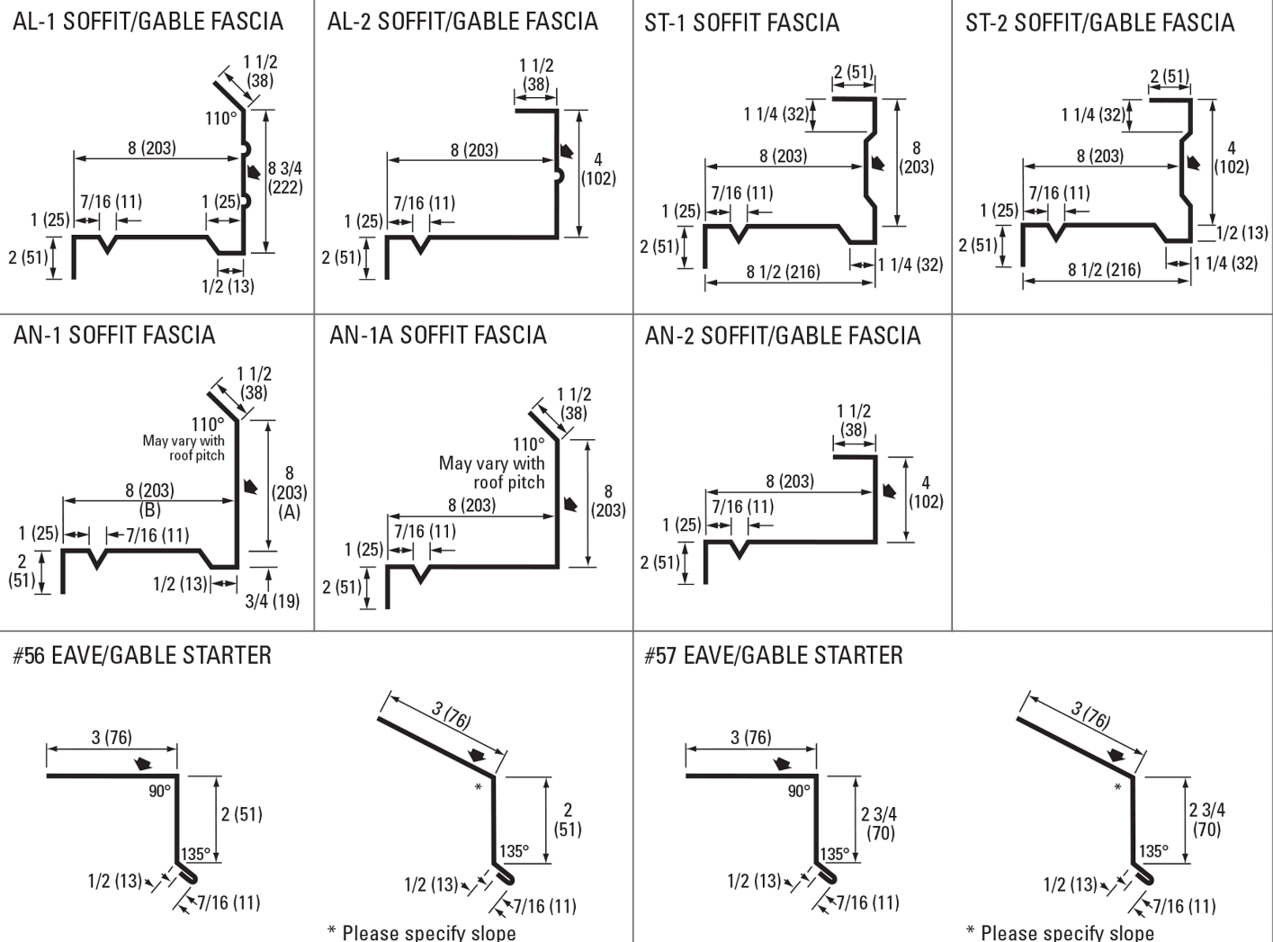
Hip Flashings, Endwalls, J-Trims, Ceiling & Sliding Door Trims
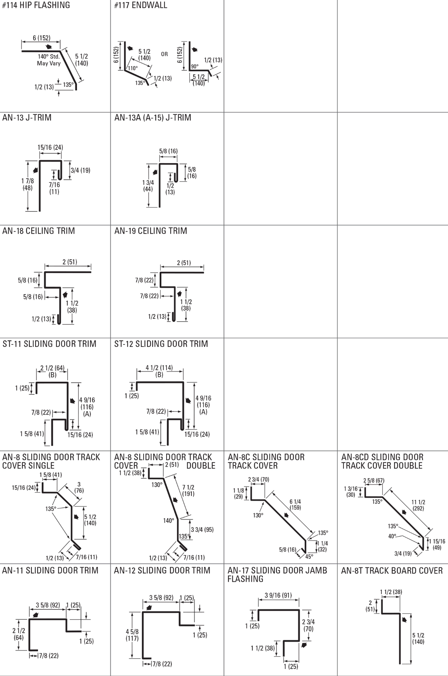
Finishes Perspectra Plus Series™
The Perspectra Plus Series™ represents the next evolution of our Perspectra Series® paint system. Enhanced with advanced Silicone Modified Polyester (SMP) technology and a new resin backbone, it offers superior resistance to chalking, fading, chemical degradation, and scratching.
Designed for maximum durability, the Perspectra Plus Series™ provides exceptional colour fade resistance, improved gloss retention, and increased scratch resistance. With a proven track record, it ensures 40 years of film integrity and 30 years of reliable colour and chalk resistance, making it ideal for roofing and cladding applications across Canada and the continental US.
Available on hot-dip galvanized steel and Galvalume™ (55% Aluminum – 45% Zinc alloy coating), the Perspectra Plus Series™ guarantees long-lasting performance and outstanding protection.

